

Bc Banking Solutions User Manual

PRG Project Milestone

By

Mphela Napo (578379), Mosifane Mosifane(577306) , Gianni Snyders(577932) , Phumlani Ntuli(577529)

Contents

Introduction 2

Main Menu 3

Apply for loan. 3

Loan Menu 4

Details capture 4

Displaying 5

# Introduction

This document is a guide for the banking solutions application that keeps track of all loans that are taken by customers based on what their profile is, it is depended on whether they are taking personal loans or business loans, which also determines the interest rate that will be applied to the loan. The document will include the mechanism of how the programs works and how it flows.

# Main Menu

This is the initial Menu that you will encounter as the program starts it will display 3 options and prompt you to choose any of them to continue or exit. The options include:

* Apply for loan – Will start the process of applying for either a business or personal loan (Enter1).
* Display loan – Will show you all the data of the loans (Enter 2).
* Exit – This closes the application (Enter 3).

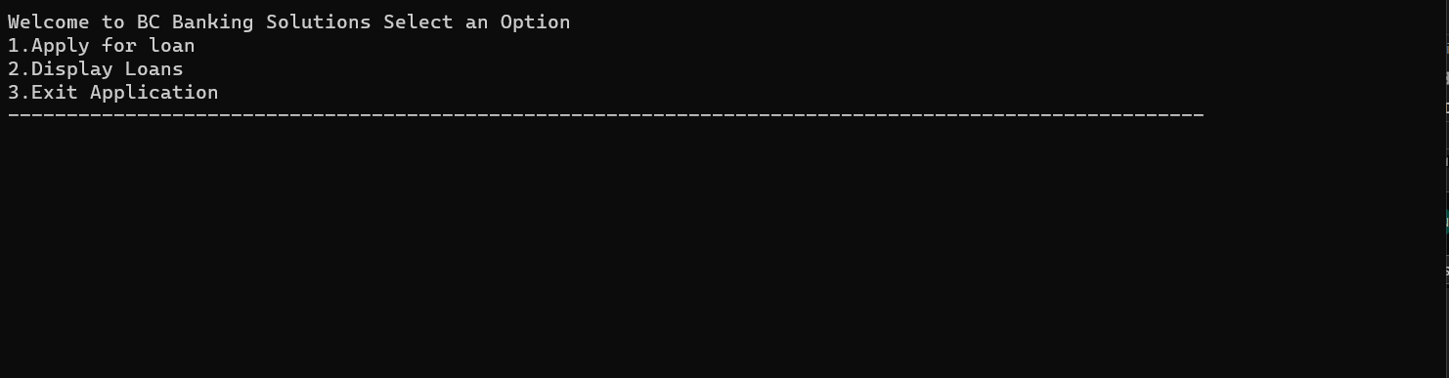

## Apply for loan.

This option begins the process of adding loan applications to a collection and applying for the loan. Before the application can continue. It will first ask the user for the current prime interest rate, so that it can be used to give the best interest rates for the loan.

### Loan Menu

Then right after the inputting of the prime interest rate the user will encounter the loan Menu, where they need to determine what type of loan they will be applying for. Two options will be displayed to the user for them to choose between applying for the business loan or the personal loan. They must enter 1 for a business loan or 2 for a personal loan.

### Details capture

After choosing a loan type the application will prompt the user to enter specific details, such as name, surname, loan amount and the term of the loan (1 year, 3 years and 5 years).

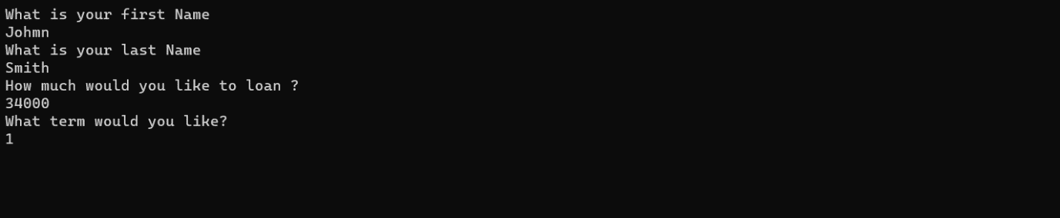

After the user is done inputting, they will be asked if they would like to enter another loan which will restart the capturing of the details or if they enter 2 it will take them to the main menu so that they can see or display the details of the main menu.



## Displaying

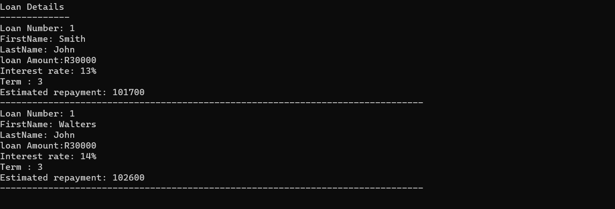

## Exit

This part of the main menu closes the application after entering 3.ssssss